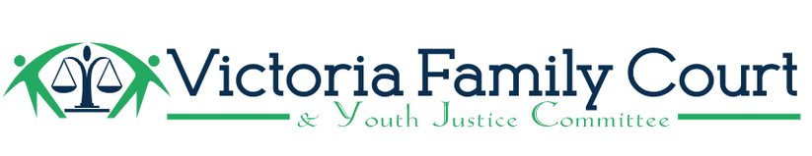

Strategic Plan 2023-2026
[Renewed: April 27, 2023]

Mission: To facilitate connections between municipal and First Nations governments, school districts, service providers, and the broader community in order to educate and advocate on the challenges and shortfalls facing youth and families who may come into contact with the justice system.

Vision: Families and youth have access to timely and appropriate supports within their communities so that they may achieve their full potential.

Goals:
- Increase awareness of the issues facing families and youth involved with the justice system, and raise the profile of the Victoria Family Court and Youth Justice Committee.
  - Identify gaps in services.
  - Support youth initiatives.
- Pursue and promote meaningful reconciliation with the Indigenous community.
  - Committee members participate in Cultural Competency Training
  - Acknowledge and compact the over-representation of Indigenous people in the justice system.
- Advocate for policies and initiatives that improve outcomes for families and youth who may come in contact with the justice system.
  - Give a platform to youth/ amplify youth voices.
- Support equity of access to resources across the region.
  - Help other organizations leverage their resources in support of families and youth.
- Facilitate collaboration between community service providers and governance bodies in the interest of better supporting youth and families.

